**Parts of a Windmill and Their Functions:**

1. **Blades (or Rotor Blades):**
   * **Function:** Capture wind energy and convert it into rotational mechanical energy. The shape of the blades (airfoil) allows wind to exert lift and drag forces, causing the blades to spin.
   * **Details:**
     + Modern windmills typically have **3 blades** for optimal efficiency and stability.
     + Blade materials: Usually made of lightweight, durable materials like fiberglass or carbon fiber.
   * **Importance:** The length and design of the blades determine how much energy can be captured.
   * **Discovered by:** Blade-like designs have existed since the Persian windmills of 500–900 AD, but modern aerodynamic blade designs emerged in the 20th century.
2. **Rotor:**
   * **Function:** The hub (central part of the rotor) connects the blades and transfers their rotational energy to the shaft.
   * **Details:** The rotor is a critical component, as it integrates the motion of the blades into the rest of the windmill's system.
   * **Importance:** Directly impacts the windmill's overall efficiency.
3. **Nacelle:**
   * **Function:** Houses the key mechanical components of the windmill, such as the gearbox, generator, and control systems.
   * **Details:** The nacelle is mounted at the top of the tower and rotates with the blades to face the wind (yaw adjustment).
   * **Importance:** Protects sensitive equipment from external elements while allowing access for maintenance.
4. **Gearbox:**
   * **Function:** Increases the rotational speed of the rotor to a speed suitable for generating electricity. For example, it converts low-speed rotation (10–20 RPM) into high-speed rotation (1,000–1,800 RPM).
   * **Importance:** Essential in turbines that rely on higher RPMs for energy generation. However, modern designs sometimes use **direct-drive systems** to eliminate the need for a gearbox.
5. **Generator:**
   * **Function:** Converts mechanical energy (rotational energy from the rotor) into electrical energy.
   * **Details:** Usually an **alternating current (AC) generator**, but some systems generate direct current (DC) electricity.
   * **Importance:** The heart of the energy conversion process, as it produces usable power for homes or the grid.
6. **Controller:**
   * **Function:** Manages the windmill's operations, including starting and stopping the windmill when wind speeds fall below or exceed safety thresholds (cut-in and cut-out speeds).
   * **Details:** Helps protect the windmill from damage during extreme weather or high winds.
7. **Tower:**
   * **Function:** Elevates the blades and rotor above the ground to capture stronger, steadier winds.
   * **Details:** Typically made of steel or reinforced concrete. The height can range from **40 to 100 meters (130–330 feet)** for land-based windmills and even taller for offshore systems.
   * **Importance:** Taller towers increase windmill efficiency, as wind speed increases with altitude.
8. **Yaw Drive and Yaw Motor:**
   * **Function:** Rotates the nacelle to face the wind for optimal energy capture.
   * **Details:** Sensors in the windmill detect the wind direction, and the yaw motor adjusts the nacelle's position accordingly.
   * **Importance:** Critical for maintaining efficiency, as improper alignment reduces energy capture.
9. **Anemometer and Wind Vane:**
   * **Function:**
     + **Anemometer:** Measures wind speed to determine whether it is within the operational range.
     + **Wind Vane:** Measures wind direction and provides data to the yaw system.
   * **Importance:** Ensures the windmill operates only in safe and efficient wind conditions.
10. **Brake System:**
    * **Function:** Stops the rotor in emergencies or during maintenance.
    * **Details:** Includes both mechanical and aerodynamic braking systems for redundancy.
11. **Base (Foundation):**
    * **Function:** Anchors the windmill to the ground, ensuring stability during high winds.
    * **Details:** Often consists of a concrete base for land-based windmills and a specialized structure for offshore systems.

**Key Discoveries and Innovations in Windmill Design**

1. **Early History:**
   * Windmills were first used in **Persia** around 500–900 AD to grind grain and pump water. These early designs were vertical-axis windmills.
   * In the **12th century**, horizontal-axis windmills were introduced in Europe, leading to the classic "Dutch windmill" design.
2. **Modern Windmills:**
   * **1890s:** Danish scientist **Poul la Cour** developed early electricity-generating wind turbines.
   * **1927:** The Darrieus wind turbine (a vertical-axis wind turbine) was patented by **Georges Darrieus**.
   * **1980s:** The first large-scale wind farms were developed in California, marking the transition to modern wind energy.

**Important Concepts Related to Windmills**

1. **Cut-in and Cut-out Speeds:**
   * **Cut-in speed:** The minimum wind speed required for the windmill to start generating electricity, usually **3–4 m/s (7–9 mph)**.
   * **Cut-out speed:** The maximum wind speed at which the windmill operates safely, typically around **25 m/s (56 mph)**.
2. **Capacity Factor:**
   * A measure of how efficiently a windmill produces energy compared to its maximum potential output. Most windmills have a capacity factor of **30–50%**.
3. **Betz’s Law:**
   * States that no wind turbine can capture more than **59.3%** of the kinetic energy in the wind. This is the theoretical maximum efficiency of a windmill.
4. **Types of Wind Turbines:**
   * **Horizontal-Axis Wind Turbines (HAWT):** Most common type; blades spin around a horizontal axis.
   * **Vertical-Axis Wind Turbines (VAWT):** Blades spin around a vertical axis; suitable for urban environments but less efficient.

**Impact of Windmills**

1. **Environmental Benefits:**
   * Clean, renewable energy source that reduces reliance on fossil fuels.
   * No greenhouse gas emissions during operation.
2. **Economic Benefits:**
   * Creates jobs in manufacturing, installation, and maintenance.
   * Reduces energy costs in the long term.
3. **Challenges:**
   * **Noise pollution:** Some turbines produce low-frequency noise.
   * **Wildlife impact:** Bird and bat mortality due to collisions with blades.
   * **Land use:** Large wind farms require significant space, potentially conflicting with agriculture or wildlife habitats.

***Diagram:***

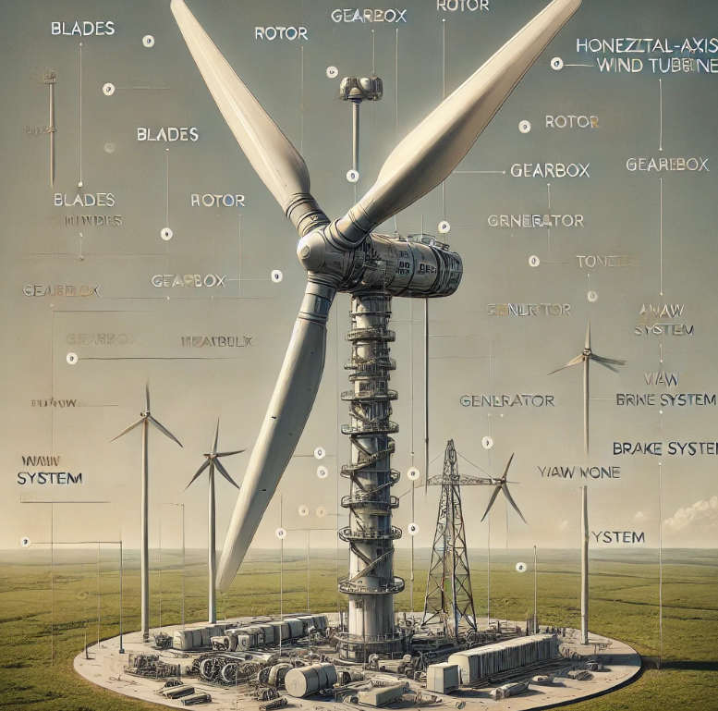

***Different Types of Wind Turbines:***

Wind turbines are devices that convert kinetic energy from the wind into electrical energy. They come in two main categories: **Horizontal-Axis Wind Turbines (HAWTs)** and **Vertical-Axis Wind Turbines (VAWTs)**.

**1. Horizontal-Axis Wind Turbines (HAWTs)**

* **Description**: These are the most common wind turbines. The rotor blades spin on a horizontal axis, typically perpendicular to the wind direction.
* **Key Features**:
  + Highly efficient.
  + Requires strong, consistent wind for optimal performance.
  + Installed on tall towers to access high-altitude winds.
* **Real-World Example**: Offshore wind farms like Hornsea Project in the UK.

**Main Parts of HAWTs**

1. **Rotor Blades**: Captures wind energy and transfers it to the hub.
2. **Hub**: Connects the blades to the shaft.
3. **Nacelle**: Houses components like the gearbox, generator, and brake.
4. **Gearbox**: Increases rotor speed to match the generator's requirements.
5. **Generator**: Converts mechanical energy into electrical energy.
6. **Tower**: Supports the turbine; the taller the tower, the better access to strong winds.
7. **Yaw Mechanism**: Rotates the nacelle to align with wind direction.

**History**

* **Discovered by**: Daniel Halladay in 1854 (for water-pumping windmills in the U.S.).
* **Modern HAWTs**: Developed in the 1930s by Palmer Putnam.

**2. Vertical-Axis Wind Turbines (VAWTs)**

* **Description**: The rotor spins around a vertical axis, parallel to the wind direction.
* **Key Features**:
  + Can capture wind from any direction.
  + Operates well in turbulent wind conditions.
  + Often used in urban areas or where wind direction changes frequently.
* **Real-World Example**: Urban installations on rooftops.

**Types of VAWTs**

1. **Darrieus Turbine**: Features a curved, egg-beater shape for high efficiency.
2. **Savonius Turbine**: Uses scoops (like a water wheel) to capture wind; good for low-speed winds.

**Main Parts of VAWTs**

1. **Blades**: Capture wind energy from any direction.
2. **Central Shaft**: Transfers the kinetic energy to the generator.
3. **Generator**: Produces electricity.
4. **Base Structure**: Provides stability.

**History**

* **Discovered by**: Georges Darrieus in 1931 (Darrieus Turbine).

**3. Hybrid Wind Turbines**

* **Description**: Combine features of HAWTs and VAWTs to improve efficiency in diverse conditions.
* **Examples**: Some hybrid turbines use vertical-axis rotors with horizontal blades.

**DIFFERENCE BETWEEN HAWTs AND VAWTs**

| **Feature** | **HAWT** | **VAWT** |
| --- | --- | --- |
| **Axis Orientation** | Horizontal | Vertical |
| **Wind Direction** | Needs consistent wind direction | Captures wind from any direction |
| **Efficiency** | Higher | Lower |
| **Usage** | Large-scale wind farms | Urban and small installations |
| **Maintenance** | Harder (at height) | Easier (at ground level) |

**VISUAL REPRESENTATION**

Below is an explanation of labeled diagrams for both types:

**HAWT Diagram Labels**

1. Rotor Blades
2. Hub
3. Nacelle (with gearbox and generator inside)
4. Tower
5. Yaw Mechanism
6. Anemometer (measures wind speed)
7. Controller

**VAWT Diagram Labels**

1. Curved Blades (Darrieus) or Scoops (Savonius)
2. Vertical Shaft
3. Generator at the base
4. Support Base

***Diagrams***:

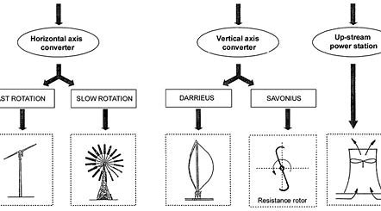

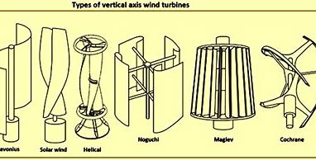

***Other Important Diagrams***:

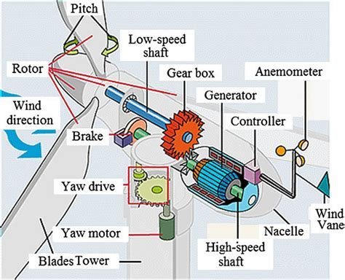

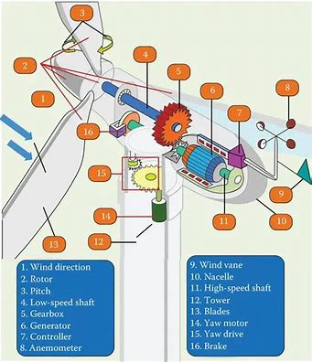

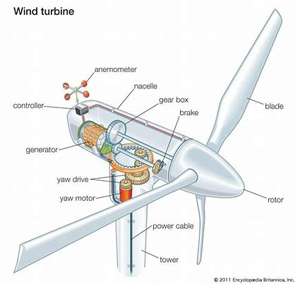

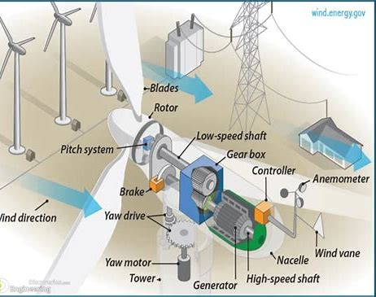

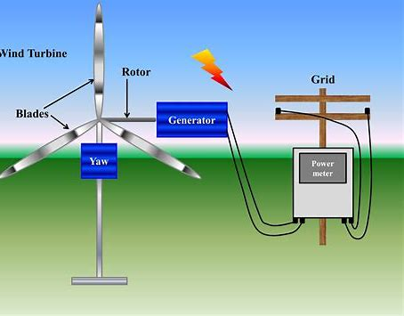

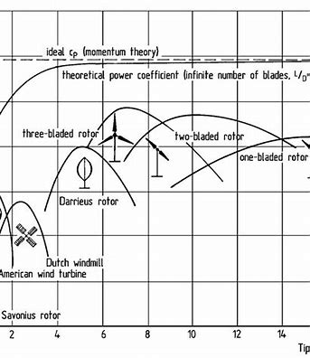

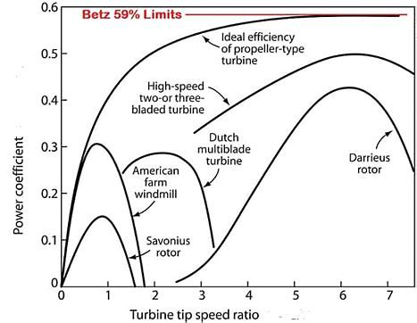

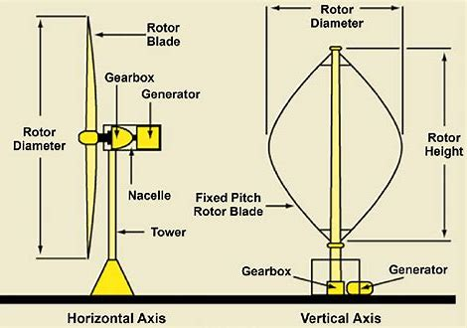

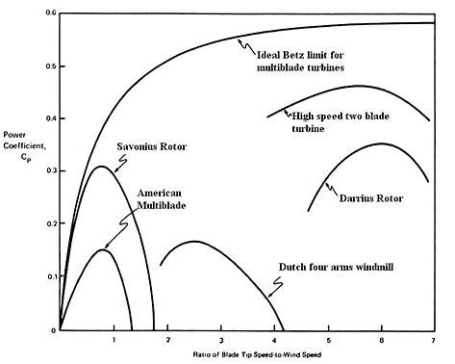

Advantages/Disadvantages of Different Windmills, and their parts.

**1. Rotor Blades**

* **Advantages**:
  + **Energy capture**: The blades are responsible for capturing wind energy and converting it into mechanical energy.
  + **Efficiency**: Modern materials and design increase the efficiency of energy capture.
  + **Environmentally friendly**: Wind energy is a clean, renewable source.
* **Disadvantages**:
  + **Noise**: Blades can produce noise, particularly in areas with low wind speeds.
  + **Wildlife impact**: Birds and bats can collide with the blades, although modern turbines are designed to minimize this.
  + **Wear and tear**: Over time, blades can degrade, especially if they’re exposed to harsh conditions, requiring maintenance or replacement.

**2. Hub**

* **Advantages**:
  + **Structural integrity**: The hub connects the rotor blades to the turbine shaft, providing stability.
  + **Simple design**: The hub is relatively simple to design and maintain.
* **Disadvantages**:
  + **Stress and fatigue**: The hub is under constant stress from wind forces and the rotation of the blades, which can lead to wear over time.
  + **Maintenance**: Any damage to the hub can be costly to repair and may require specialized parts.

**3. Nacelle**

* **Advantages**:
  + **Protection**: The nacelle houses the generator, gearbox, and other components, protecting them from the elements.
  + **Easy access for maintenance**: The nacelle provides a centralized location for easy maintenance of key components.
* **Disadvantages**:
  + **Weight**: The nacelle is heavy and can be difficult and expensive to transport and install.
  + **High cost**: It houses multiple critical components, making it a relatively expensive part of the turbine.

**4. Gearbox**

* **Advantages**:
  + **Speed conversion**: It converts the low-speed rotation of the rotor blades into the high-speed rotation needed by the generator.
  + **Powerful output**: Helps achieve the high rotational speeds required for efficient energy production.
* **Disadvantages**:
  + **Maintenance**: Gearboxes have moving parts that wear out over time and require regular lubrication and maintenance.
  + **Failure risk**: Gearbox failure is a common problem in wind turbines, leading to expensive repairs and downtime.

**5. Generator**

* **Advantages**:
  + **Energy conversion**: It converts the mechanical energy from the rotor blades into electrical energy, which is the key function of the turbine.
  + **Reliable**: Modern generators are highly efficient and can operate for long periods with minimal maintenance.
* **Disadvantages**:
  + **Efficiency loss**: Generators can sometimes suffer from energy losses due to mechanical and electrical inefficiencies.
  + **Cost**: High-quality generators can be expensive to manufacture and replace.

**6. Yaw Motor**

* **Advantages**:
  + **Wind direction adjustment**: The yaw motor allows the turbine to rotate and align itself with the wind, optimizing energy capture.
  + **Improved efficiency**: Ensures the rotor is always facing into the wind, maximizing energy production.
* **Disadvantages**:
  + **Power consumption**: The yaw system requires energy to operate, which slightly reduces the overall efficiency of the turbine.
  + **Wear and tear**: The motor can degrade over time, and repairs can be costly.

**7. Tower**

* **Advantages**:
  + **Height and accessibility**: The tower elevates the turbine components, positioning them in areas with stronger winds.
  + **Structural support**: Provides a sturdy base for the rotor, nacelle, and other components.
* **Disadvantages**:
  + **Cost**: Towers are expensive to produce and install, and they require heavy-duty materials to withstand the forces from the turbine.
  + **Visual impact**: Towers can be visually intrusive, especially in areas of natural beauty or residential areas.
  + **Maintenance**: Maintaining towers, particularly in offshore locations, can be challenging and expensive.

**8. Anemometer**

* **Advantages**:
  + **Wind speed measurement**: It provides real-time data about wind speed, allowing the turbine to optimize its operations based on wind conditions.
  + **Performance monitoring**: Helps in monitoring turbine efficiency and predicting potential failures.
* **Disadvantages**:
  + **Vulnerability to environmental factors**: The anemometer can be damaged by harsh weather, leading to inaccurate readings.
  + **Cost**: While not overly expensive, the cost of precision anemometers can add up over time.

**9. Pitch Control System**

* **Advantages**:
  + **Regulates blade angle**: The pitch control system adjusts the angle of the blades to control turbine speed and prevent damage during high winds.
  + **Maximized efficiency**: Allows the turbine to optimize its performance across different wind speeds.
* **Disadvantages**:
  + **Complexity**: The system adds complexity to the turbine and may require specialized knowledge for maintenance and repairs.
  + **Risk of malfunction**: If the system fails, it can lead to underperformance or turbine damage.

**10. Brake System**

* **Advantages**:
  + **Safety**: The brake system allows the turbine to stop in high winds or in emergencies, preventing mechanical damage.
  + **Control**: Provides additional control over the turbine’s speed and operation.
* **Disadvantages**:
  + **Wear and tear**: The brake components are subject to high levels of friction, leading to wear over time and potentially expensive repairs.
  + **Power loss**: If used excessively, the brake system may result in a loss of energy output.

**1. Horizontal-Axis Windmills (HAWTs)**

**Description**:  
Horizontal-axis windmills have blades that rotate around a horizontal axis. These are the most common type of wind turbines used for electricity generation.

**Advantages**:

* **Efficiency**: They are highly efficient at converting wind energy into mechanical energy or electricity.
* **Widely used**: These windmills are used in both onshore and offshore wind farms.
* **Better performance**: HAWTs perform better in areas with consistent and high wind speeds.

**Disadvantages**:

* **Requires consistent wind direction**: These windmills need to be oriented toward the wind, which typically requires a yaw mechanism to rotate the blades.
* **Height**: These turbines need to be placed at significant heights to access stronger winds, which increases the cost.
* **Noise and visual impact**: The spinning blades can create noise and may impact the aesthetic of landscapes, especially in populated areas.

**2. Vertical-Axis Windmills (VAWTs)**

**Description**:  
Vertical-axis windmills have blades that rotate around a vertical axis. The main types are the Darrieus and Savonius designs, which differ in the shape and structure of their blades.

**Advantages**:

* **Omni-directional**: VAWTs do not need to be oriented into the wind, making them more suitable for turbulent or variable wind conditions.
* **Compact design**: They are more compact and can be placed closer to the ground, making them easier to maintain and less expensive to install.
* **Less noise**: VAWTs are generally quieter than HAWTs.
* **No need for yawing mechanism**: VAWTs can operate in any wind direction without the need for additional machinery to adjust their orientation.

**Disadvantages**:

* **Lower efficiency**: VAWTs typically have lower efficiency compared to HAWTs, especially in terms of energy production.
* **Higher mechanical stress**: The rotational axis is typically near the ground, which can create more mechanical wear on the structure.
* **Less suited for large-scale power generation**: They are more commonly used in smaller, localized applications (like residential or small business energy needs).

**Types**:

* **Darrieus Windmill**: Shaped like a vertical “egg-beater,” the Darrieus turbine is known for its high efficiency, but it requires a starting mechanism since it’s not self-starting.
* **Savonius Windmill**: This type has a simple, scooped design and is often used for low-speed wind conditions. It’s typically used for smaller applications such as water pumping.

**3. Post Windmills**

**Description**:  
Post windmills have a vertical shaft with a single vertical post supporting the windmill structure. Historically used for water pumping and grain milling, post windmills are a more traditional design.

**Advantages**:

* **Simple design**: They have a simple mechanical design, making them relatively easy to construct and repair.
* **Effective for low wind speeds**: Suitable for areas with low wind speeds, as the large sails can capture even light breezes.
* **Low maintenance**: Compared to modern wind turbines, post windmills are easier to maintain due to their mechanical simplicity.

**Disadvantages**:

* **Lower efficiency**: The design doesn’t allow for optimal energy conversion, especially compared to modern turbines.
* **Limited power output**: Typically used for smaller, localized applications, such as pumping water or grinding grain.
* **Limited scalability**: Post windmills are not suitable for large-scale energy generation.

**4. Smock Windmills**

**Description**:  
Smock windmills are a type of post windmill that has a rotating cylindrical structure on top of a brick or stone base. They are historically used in Europe, especially for milling grain.

**Advantages**:

* **Traditional design**: Smock windmills have a classic, iconic design that is often a part of the cultural heritage in rural areas.
* **Large sail area**: They can capture a lot of wind, making them efficient for their size.

**Disadvantages**:

* **Limited by location**: Their location near communities makes them less effective at generating large amounts of power compared to modern turbines.
* **Maintenance**: The rotating structure and mechanical parts can be challenging to maintain.

**5. Tower Windmills**

**Description**:  
Tower windmills are a variation of the post windmill, where the mill’s body is placed on top of a stone or brick tower. The design allows for larger sails, improving efficiency.

**Advantages**:

* **Better wind exposure**: The tower allows the windmill to capture higher and more consistent wind speeds.
* **More durable**: The elevated structure protects the moving parts from ground moisture, improving longevity.

**Disadvantages**:

* **Complexity**: The tower structure is more complicated and expensive to build.
* **Higher maintenance costs**: The height and complexity make maintenance more difficult and costly.

**6. Wind-Pumps**

**Description**:  
Wind-pumps are simpler windmills, typically used for pumping water rather than generating electricity. They are commonly seen in rural and agricultural areas.

**Advantages**:

* **Simple and cost-effective**: Wind-pumps are simpler than electric wind turbines, making them cheaper to produce and install.
* **Water pumping**: They are ideal for pumping water in rural and farming areas without relying on the electric grid.

**Disadvantages**:

* **Limited function**: Wind-pumps are not designed for power generation and cannot be scaled for large energy production.
* **Weather-dependent**: Like other windmills, their performance is heavily dependent on wind conditions.

**Summary Table:**

| **Type of Windmill** | **Common Use** | **Key Advantages** | **Key Disadvantages** |
| --- | --- | --- | --- |
| **Horizontal-Axis Windmills (HAWTs)** | Electricity generation | High efficiency, better performance in strong winds | Needs orientation into the wind, high cost, noise |
| **Vertical-Axis Windmills (VAWTs)** | Small-scale energy, residential, water pumping | Omni-directional, compact, quieter | Lower efficiency, more wear on components |
| **Post Windmills** | Water pumping, grain milling | Simple, effective for low wind speeds | Low efficiency, limited scalability |
| **Smock Windmills** | Grain milling, historical use | Large sail area, iconic design | Low efficiency, limited power output |
| **Tower Windmills** | Milling, historical use | Better wind exposure, more durable | Complex, higher maintenance costs |
| **Wind-Pumps** | Water pumping in rural areas | Simple, cost-effective, great for irrigation | Limited function (not for power generation) |